Evaluating Field Key Design Choices and Their Impact on Early-Stage LLM Output Quality
Authors: Austin Cherian, Amanda Rankin, Melford Spiff-Rufus

Abstract
Field keys play a central role in shaping LLM outputs during early-stage generation in the text summary workflow, where contextual grounding is limited, and user trust is most fragile. This study evaluated how different field key characteristics, such as syntax, semantic alignment, and use of a standardized library, affect output quality under controlled, low-context conditions.
Across three A/B tests, quantitative differences in output quality were modest and inconsistent. More importantly, the experimentation process surfaced recurring failure modes that were largely driven by upstream field design and configuration decisions rather than field key choice alone. Conditional field titles, ambiguous field scope, and over-specification via library definitions frequently led to hallucinated or misaligned outputs that could not be mitigated through field key optimization.
These findings suggest that improving output quality requires shifting focus away from universal field key rules toward clearer configuration boundaries, better field-level feedback mechanisms, and earlier validation of field appropriateness. As field keys are expected to play a larger role in dynamic prompting across workflows, addressing these systemic issues is critical before scaling field-key–driven logic further.

1. Introduction

1.1 Background
Field keys are internal identifiers used to represent the intended meaning of text fields in customer EHRs. They help determine what the LLM generates for a given field and exert the strongest influence early in the generation pipeline before RAG, organizational examples, or downstream metadata are applied.
This early stage is both technically and operationally important. With minimal context available, the model leans heavily on the field key to infer intent. It is also often the first point at which users encounter generated content, making it a high-risk moment for trust. Poor or irrelevant outputs at this stage can disproportionately affect adoption and confidence in the system.
By contrast, the live audio workflow currently produces static outputs that are independent of field keys and includes guardrails that limit generation to content explicitly mentioned in the session. As a result, some failure modes observed in text summary do not currently surface in live audio.
However, this distinction is expected to narrow as dynamic prompting is introduced to live audio and field keys play a larger role across both workflows. In this context, existing configuration issues and field-level assumptions are likely to compound rather than disappear, and additional configuration failure modes specific to live audio may emerge. Understanding these risks early is therefore important before scaling field-key–driven logic more broadly.

1.2 Motivation
Existing guidance on field key creation, including preferred syntax, semantic clarity, and the use of a standardized library, has largely been based on heuristics and anecdotal experience. It is often unclear whether observed output issues stem from the field key itself, the field title it represents, or broader configuration decisions.
This work was motivated by a desire to better understand those distinctions. Rather than attempting to establish definitive best practices, the goal was to probe how different field key choices behave in isolation and to surface common failure modes that emerge during testing.

1.3 Research Questions
This study focused on three questions:
- Does field key syntax (e.g., snake_case vs. camelCase) meaningfully affect output quality when semantics are held constant?
- Does stronger semantic alignment between a field key and its field title improve output relevance?
- Do standardized library field keys consistently outperform semantically similar non-library alternatives?
These questions were intended to clarify when field key design choices meaningfully influence behavior in low-context settings and when other factors dominate.

2. Methods

2.1 Experimental Setup
All tests were run using a Data Science Tool, which connects directly to the LLM prompt within the Eleos Documentation text summary workflow. The tool bypasses organizational context, retrieval-based examples, and downstream metadata, allowing the field key to act as the primary conditioning signal.
For consistency across tests, the session bullet points used in the text summary workflow were sourced from the General Therapy section of the text input document and held constant across all experiments. This setup approximates a zero-shot, low-context environment and isolates the effect of field key variation on output quality. While this does not reflect full production behavior, it mirrors the earliest stage of generation in the text summary flow, where the field key carries most of the semantic load.
To support controlled comparisons, an internal analysis pipeline was used to evaluate field keys in production based on their semantic alignment with the corresponding field titles. This pipeline identified a subset of field keys with low semantic alignment (“poor” field keys) and, for each, generated a suggested alternative designed to better reflect the field title’s intended meaning (“improved” field keys).
Across relevant A/B tests, Variant A was drawn from this set of low-alignment production field keys and served as the baseline/control condition, while Variant B was the corresponding pipeline-suggested field key intended to improve semantic alignment with the field title.

2.2 Output Evaluation
Outputs were recorded in a shared Google Sheet and manually graded by a single evaluator (Amanda Rankin) based on relevance, coherence, and alignment with the intended purpose of the field. Outputs that introduced unsupported, speculative, or hallucinated content were consistently scored lower, as hallucination was treated as a primary indicator of poor output quality in low-context settings. This evaluation served as a practical proxy for how early-stage outputs would be perceived by end users.
This approach introduces subjectivity and limits generalizability, but it enabled rapid iteration and close inspection of failure cases. Qualitative observations, particularly around hallucination triggers and configuration-driven errors, were treated as equally important to numerical scores and often provided clearer insight than aggregate score differences.

2.3 A/B Test Designs

2.3.1 Test 1: Syntax
This test evaluated whether syntactic formatting alone influences output quality when semantic meaning is held constant.
Variant A consisted of the original low-alignment (“poor”) production field key. Variant B consisted of the corresponding pipeline-suggested field key expressed in one of three syntactic formats: snake_case, camelCase, or concatenated/glued tokens. As a result, each Variant A was compared against three Variant B syntactic variants.
Field title, input bullets, and prompt structure were held constant across all comparisons to isolate syntax as the independent variable.

2.3.2 Test 2: Semantic Alignment
This test evaluated whether semantic alignment between a field key and its corresponding field title affects output quality. Variant A consisted of the original low-alignment (“poor”) production field key identified by the analysis pipeline as having low semantic alignment. Variant B consisted of the corresponding pipeline-suggested (“improved”) field keys designed to better match the meaning of the field title.
This comparison directly tested whether improving semantic alignment, independent of syntax or configuration changes, resulted in more relevant and appropriate outputs.

2.3.3 Test 3: Field Key Library Validation
This test assessed whether standardized field keys drawn from the official field key library consistently outperform semantically equivalent non-library alternatives. Variant A was a field key in production and in the field key library. Variant B was a semantically equivalent field key created for testing purposes but not included in the library.
The goal of this comparison was to evaluate whether library membership alone confers output quality benefits or whether performance depends on contextual alignment and field design.

2.4 Analytical Approach
Results were analyzed descriptively. Average scores were used to summarize trends, while a qualitative review was used to identify recurring patterns and failure modes. Given the small sample size and subjective grading, no statistical significance testing was performed.
The analysis emphasizes interpretability and procedural insight over quantitative comparison.

3. Results

3.1 Syntax A/B Test
Across evaluated fields, snake_case and camelCase variants showed slightly higher average scores than glued-token formats. Glued-token field keys did not show improvement over the control condition.
However, syntax effects were inconsistent at the individual field level. Several fields showed no change across syntax variants, and at least one showed decreased quality with alternative syntax. Overall, syntax appeared to have a limited and non-deterministic impact on output quality when considered in isolation.
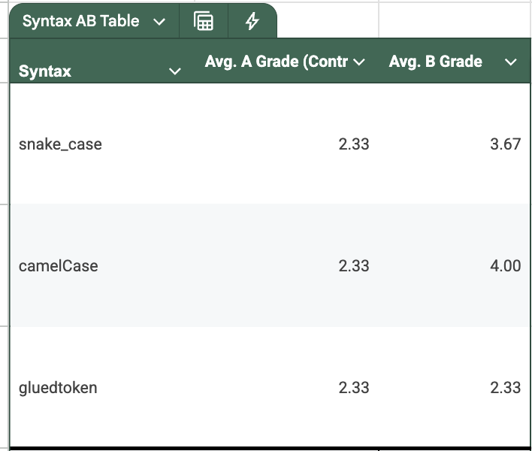Table 1. Syntax A/B test results comparing average output quality scores for snake_case, camelCase, and glued-token field key formats (N = 9).

3.2 Semantic Alignment A/B Test
Semantically aligned field keys generally scored higher than their original counterparts, particularly for fields that were broad or underspecified. In these cases, increased semantic clarity appeared to help constrain the structure and focus of generated outputs.
Fields with already specific or well-scoped keys showed little to no change. Several comparisons resulted in ties, suggesting that semantic alignment primarily matters when baseline alignment is weak.
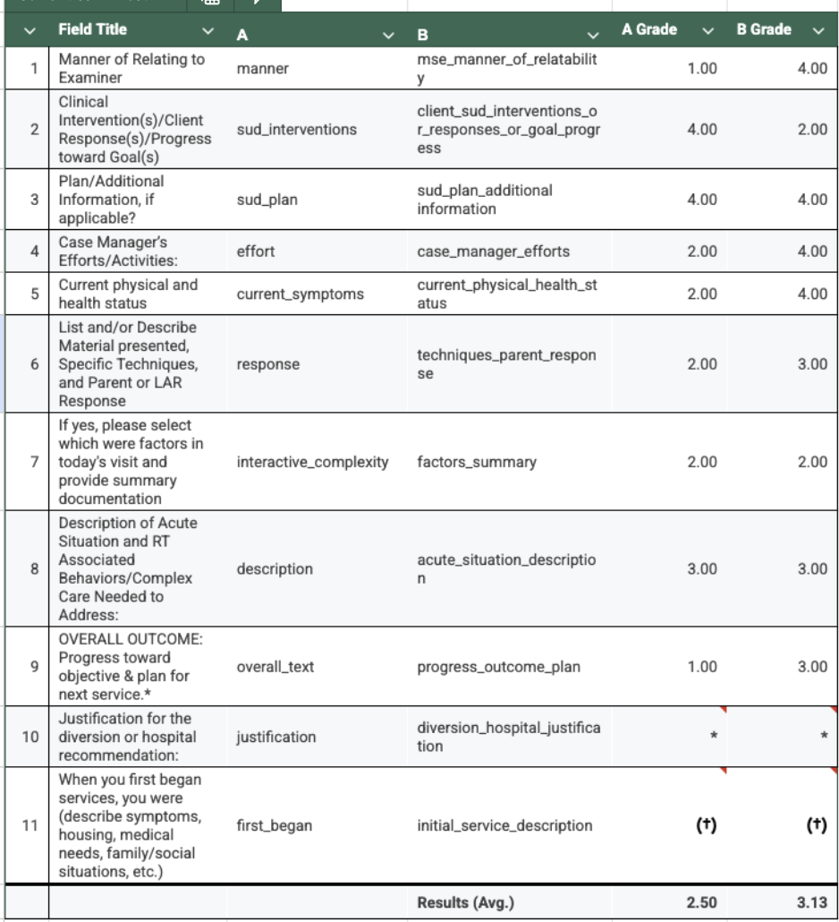

Table 2. Semantic alignment A/B test results comparing original production field keys and semantically aligned alternatives (N = 11). ^{(*)(†)}Rows 10 and 11 were not graded due to significant systemic issues unrelated to the variable under test (see Results Section 4.1.3).

3.3 Field Key Library Validation Test
Results from the library validation test were mixed. In some cases, library field keys produced higher-quality outputs, but in others, non-library alternatives performed equally well or better. On average, non-library keys scored higher across the evaluated sample.
Qualitative review showed that library keys sometimes introduced expectations not supported by the input bullets, leading to speculative or unsupported content. This suggests that library effectiveness is highly dependent on how well the definition aligns with both the field title and available context.
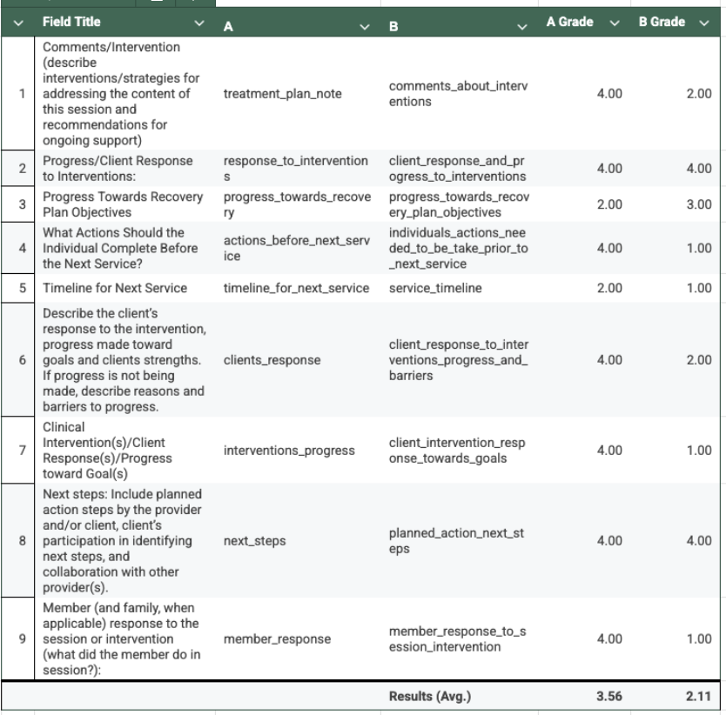

Table 3. Field key library validation A/B test results comparing standardized library field keys and semantically similar non-library alternatives (N = 9).

3.4 Results Overall Summary
This study was exploratory by design, and the quantitative results alone are not sufficient to directly inform implementation playbooks. While sample sizes were small and multiple confounding factors, such as field title ambiguity and configuration-driven hallucination limit the ability to attribute observed differences to any single variable, the experimentation process nonetheless surfaced several structural and procedural issues that consistently affected output quality. In many cases, these factors had a larger impact than individual field key choices. As such, the findings should be interpreted as exploratory and descriptive rather than statistically significant or causal, and they help inform areas for further investigation and implementation refinement.

4. Analysis and Future Recommendations

4.1 Sources of Failure Observed During Testing
Across all A/B tests, several recurring failure modes emerged. Importantly, many of these failures could not be resolved through field key optimization alone and instead stemmed from upstream design and configuration decisions.
Examples below are representative cases selected to illustrate recurring failure patterns; full results are available in Tables 2 and 3.

4.1.1 Conditional Field Titles
Conditional field titles (e.g., “If yes, please explain…”) consistently generated outputs regardless of whether the condition was met. Because the model lacks the context needed to evaluate the condition, generation was effectively unconditional, resulting in hallucinated content even when field keys were syntactically clean and semantically aligned.
Representative example (see Table 2, Row 7):
- Field title: “If yes, please select which were factors in today’s visit and provide summary documentation”
- Observed issue: The model generated content even when the prerequisite condition (“yes”) was not met, resulting in unsupported documentation.

4.1.2 Field Title Ambiguity
Some field titles lacked sufficient specificity to clearly define what content was expected. In these cases, it was difficult to determine whether poor outputs were driven by the field key, the title itself, or the absence of contextual grounding. This ambiguity limits the interpretability of field key quality scores and complicates attribution during evaluation.

Representative example (see Table 2, Row 4):
- Field title: “Case Manager’s Efforts/Activities”
- Field keys tested: effort (A) vs. case_manager_efforts (B)
- Observed issue: The model interpreted “effort” as referring to client effort rather than clinician activity, leading to misaligned output.

4.1.3 Configuration Scope Mismatch
Certain fields were configured despite falling outside the intended scope of the tool. In these scenarios, hallucinated or inappropriate outputs were often inevitable, regardless of field key design. Examples included:
- Discharge summary fields, which are not tied to a single service or session
- Psych Assessment fields that implicitly require diagnostic judgments
Representative example (see Table 2, Row 11):
- Field title: “When you first began services, you were (describe symptoms, housing, medical needs, family/social situations, etc.)”
- Observed issue: The field functioned as a discharge summary rather than a session-level note, making generation inappropriate by design.

4.1.4 Over-Specification via Library Field Keys
In some cases, standardized library field keys introduced expectations not supported by the input bullet content. While this occasionally resulted in more structured outputs, it also increased the likelihood of unsupported or speculative content when required information was missing. This tradeoff between specificity and grounding was not consistently captured by quality scores.
Representative example (see Table 3, Row 5):
- Field title: “Timeline for Next Service”
- Field keys tested: timeline_for_next_service (A: library) vs. service_timeline (B)
- Observed issue: The library key definition implied specific scheduling details, which led the model to hallucinate a future session date that was not present in the input.

4.2 Implications for Iteration
Taken together, these failure modes suggest that future efforts should focus less on universal field key rules and more on upstream decisions that determine whether generation is appropriate at all.
Key implications include:
- Evaluating whether a field should be generated unconditionally before attempting to optimize its field key
- Treating field title clarity as a prerequisite for meaningful field key evaluation
- Recognizing that some hallucination risks are configuration-driven and cannot be mitigated through semantic refinement alone

4.3 Action Steps

4.3.1 Recommendations for Implementation Playbooks
Based on observed systemic failures, the following changes should be considered for implementation guidance:
- Define configuration boundaries
  - Field key optimization cannot compensate for an invalid field scope
  - Examples:
    - Discharge summary fields that require context from previous sessions should not be configured
    - Psych Assessment fields that implicitly require diagnosis should not be configured, or more explicit guardrails need to be included in prompting and validated to be working.
- Avoid conditional fields
  - Conditional titles (“If yes…”) trigger text suggestions regardless of context and, therefore, are susceptible to hallucination
- Clarify field intent before optimizing field keys
  - For text field titles that are ambiguous or underspecified, the intended purpose of the field should be clarified with the organization before attempting field key optimization. Without a clear understanding of what content is expected in a given text field, it is not possible to meaningfully evaluate or improve the corresponding field key.
- When the field intent cannot be clearly established, the field should be reconsidered for configuration, as an ambiguous scope increases the likelihood of irrelevant or hallucinated outputs regardless of field key design.
- Use library keys selectively
  - Library field keys should be applied only when their definitions align with both the field title and that field’s expected content.

4.3.2 Feedback and QA Improvements
Current feedback mechanisms do not support reliable evaluation of field-key-level performance in production. Feedback is collected at the user level without reference to the specific progress note, workflow, or text field it applies to. As a result, identifying “problematic” field keys or configurations relies largely on inference and anecdotal signals rather than direct user evidence.
Without field-level feedback, efforts to diagnose root causes of poor outputs remain speculative. It is often unclear whether an issue stems from the field key, the field title, the configuration itself, or user expectations, limiting the ability to make targeted improvements.
Recommended improvements include:
- Enhancing progress note feedback forms to capture:
  - The specific text field being evaluated
  - The associated progress note and workflow
- Incorporating proxy signals such as kept-text rate (the percentage of suggested text that a user retains in their final submitted note). When tracked at the individual field level, keep-text rate can provide a scalable, behavior-based signal of output usefulness without requiring explicit user feedback.
- Introducing preventative QA during technical readiness calls by:
  - Generating representative outputs using the Sidebar.
  - Reviewing those outputs with the organization to validate alignment with intended documentation behavior before rollout
Together, these changes would shift field key evaluation from retrospective guesswork toward evidence-driven diagnosis and earlier detection of configuration issues.

4.4 Future Investigations
Several open questions emerged that warrant further investigation:
- Scaling evaluation
  - Re-running similar tests with larger sample sizes and controls for identified confounders (field title clarity, configuration scope)
- Guardrails in field keys
  - Does explicitly encoding guardrails within field keys reduce unwanted content in low-context generation?
- Library over-specification
  - Are some library field key definitions overly specific for uncontrolled or mixed-use contexts?
  - Should library keys explicitly state program scope (e.g., therapy vs. case management)?
- Field key analysis pipeline
  - Continuing to validate the field key analysis pipeline and improve it to
    - Systematically identify high-risk field keys
    - Suggest semantically aligned alternatives at scale
    - Prioritize candidates based on observed failure patterns rather than the score alone

4.5 Closing Note
This work was exploratory and diagnostic in nature. While the A/B tests provided limited evidence that syntax, semantic alignment, or library usage alone reliably improve output quality, they were effective in revealing where and why the system fails under low-context conditions.
The most significant issues identified were not tied to specific field key implementations, but to broader configuration choices such as conditional fields that always trigger generation, fields whose scope exceeds what the tool can support, and ambiguous field titles that leave intent underspecified. In these cases, field key optimization offered little benefit and, at times, exacerbated hallucination risk.
The key takeaway is that field keys operate within a narrow band of influence. Their effectiveness depends heavily on upstream decisions about what is configured, how fields are framed, and what evidence is available to evaluate real-world performance. Without field-level user feedback, diagnosing problems remains largely speculative, limiting the ability to make targeted improvements.
As Eleos moves toward more dynamic prompting across workflows, existing configuration assumptions and failure modes are likely to compound rather than disappear. The findings from this study provide a foundation for improving configuration practices, strengthening feedback and QA processes, and guiding future investigation, ensuring that field-key–driven logic scales in a way that is both safe and aligned with user expectations.

